Guidelines for FN-support:

- All applicants and participants who can receive support must be members of FN

- All documentation, including receipts and membership numbers, must be collected in one application form (which can be found on the next page), and it must clearly state which expenses there are wanted covered. (E.g. by making an Excel table in which the sub-amounts and sum for them appear relevant expenses)

- You can apply for money up to 2 months before or up to 2 months after the event held.

- You can apply for DKK 500 for social events and DKK 750 for events with a professional purpose content per FN member.

- You cannot apply for financial support for alcohol

- It is not required to create an event through the FN Facebook page

- The event must not be in collaboration with an interest group

- Please send the application to naturstud@gmail.com
The subject field must include:
1) "FN-support"
2) Who is applying (name of responsible person)
3) Which event is applied for (incl. date of the event)

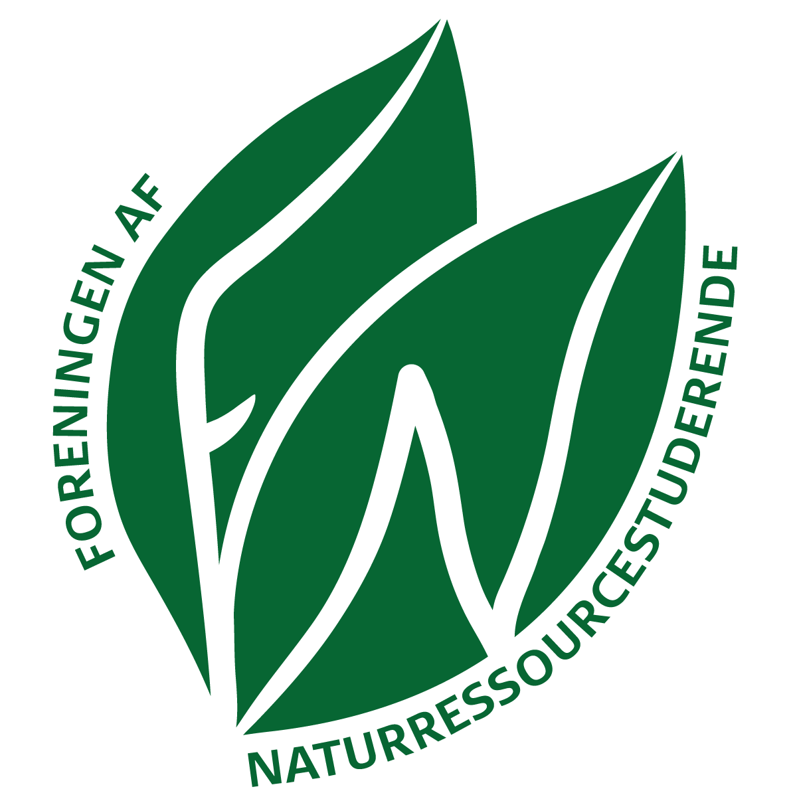
Application form to FN

Husk at alle der søger om økonomisk støtte, skal være medlem af FN.
Remember, you must be a member of FN to receive economical support.
Husk at indsætte kvitteringer for det ansøgte beløb!
Remember to insert receipt(s) for the amount requested

Husk at der søges med tilbagevirkende kraft (dvs. når de relevante kvitteringer kan medsendes)
Remember that all relevant receipts need to be attached before you submit the application.

Ansøgers navn
Name of applier
Kontonummer  Bank Account Number | Reg  Konto:
Hos FN søges om økonomisk støtte til: (kort beskrivelse)
Description of what is applied for
Samlet beløb der ønskes dækket
Total ammount requested
Hvor mange forventes at deltage/har deltaget i arrangementet?
How many participants?
Fulde navne på deltager(/e, hvis flere ansøger sammen)
Full name of participant(s)

Application form to FN (II)

Supplerende oplysninger om det/de besøgte sted(er):
Further information of the visited place(s):

Kontaktpersonens navn og evt. firmanavn
Name of contact person and/or name of Company
Adresse
Adress
Telefon
Phone number

Dokumentation for afholdte udgifter skal indsættes i ansøgningen.
Documentation for already held expenses shall be attached this application form.

FN-medlemsdokumentation skal indsættes. Gyldig dokumentation er f.eks. kvittering for betaling af sidste kontingentregning til JA.
Documentation of FN-membership must be attached. Valid documentation is for example a receipt of the last quota paid to JA.

